**Chapter 2**

**Vectors in Space**

**2.3 The Dot Product**

**Section Exercises**

**For the following exercises, the vectors u and v are given. Calculate the dot product **

123.  

Answer: 6

124.  

Answer: 0

125.  

Answer: 0

126.  

Answer: 8

**For the following exercises, the vectors a, b, and c are given. Determine the vectors  and  Express the vectors in component form.**

127.   

Answer:  

128.   

Answer:  

129.   

Answer:  

130.   

Answer:  

**For the following exercises, the two-dimensional vectors a and b are given.**

1. **Find the measure of the angle  between a and b. Express the answer in radians rounded to two decimal places, if it is not possible to express it exactly.**
2. **Is  an acute angle?**

131. **[T]** 

Answer: a.  rad; b.  is not acute.

132. **[T]** 

Answer: a.  rad; b.  is acute.

133.  =

Answer: a.  rad; b.  is acute.

134.  

Answer: a.  rad; b.  is not acute.

**For the following exercises, find the measure of the angle between the three-dimensional vectors a and b. Express the answer in radians rounded to two decimal places, if it is not possible to express it exactly.**

135.  

Answer: 

136.  

Answer: 

137.  

Answer: 

138.  

Answer: 

139. **[T]**  where  and 

Answer: rad

140. **[T]**  where  and 

Answer:  rad

**For the following exercises determine whether the given vectors are orthogonal.**

141.   where *x* and *y* are nonzero real numbers

Answer: Orthogonal

142.   where *x* and *y* are nonzero real numbers

Answer: Orthogonal

143.  

Answer: Not orthogonal

144.  

Answer: Not orthogonal

145. Find all two-dimensional vectors **a** orthogonal to vector  Express the answer in component form.

Answer: , where  is a real number

146. Find all two-dimensional vectors **a** orthogonal to vector  Express the answer by using standard unit vectors.

Answer:  where  is a real number

147. Determine all three-dimensional vectors **u** orthogonal to vector  Express the answer by using standard unit vectors.

Answer:  where  and  are real numbers such that 

148. Determine all three-dimensional vectors **u** orthogonal to vector  Express the answer in component form.

Answer:  where and  are real numbers such that 

149. Determine the real number  such that vectors  and  are orthogonal.

Answer: 

150. Determine the real number such that vectors  and  are orthogonal.

Answer: 

151. **[T]** Consider the points  and 

1. Determine vectors  and  Express the answer by using standard unit vectors.
2. Determine the measure of angle *O* in triangle *OPQ*. Express the answer in degrees rounded to two decimal places.

Answer: a.   b. 

152. **[T]** Consider points  and 

1. Determine vectors  and  Express the answer in component form.
2. Determine the measure of angle *B* in triangle *ABC*. Express the answer in degrees rounded to two decimal places.

Answer: a.   b.

153. Determine the measure of angle *A* in triangle *ABC*, where  and  Express your answer in degrees rounded to two decimal places.

Answer: 

154. Consider points  and  Determine the angle between vectors  and  Express the answer in degrees rounded to two decimal places.

Answer: 

**For the following exercises, determine which (if any) pairs of the following vectors are orthogonal.**

155.   

Answer: **u** and **v** are orthogonal; **v** and **w** are orthogonal.

156.   

Answer: **u** and **w** are orthogonal.

157. Use vectors to show that a parallelogram with equal diagonals is a square.

158. Use vectors to show that the diagonals of a rhombus are perpendicular.

159. Show that  is true for any vectors **u**, **v**, and **w**.

160. Verify the identity  for vectors   and 

**For the following problems, the vector u is given.**

1. **Find the direction cosines for the vector u.**
2. **Find the direction angles for the vector u expressed in degrees. (Round the answer to the nearest integer.)**

161. 

Answer: a.  and  b.   and 

162. 

Answer: a.  and  (b)   and 

163. 

Answer: a.  and  b.   and 

164. 

Answer: a.  and  b.   and 

165. Consider  a nonzero three-dimensional vector. Let   and  be the directions of the cosines of **u**. Show that 

166. Determine the direction cosines of vector  and show they satisfy 

Answer:   and  Indeed, 

**For the following exercises, the vectors u and v are given.**

1. **Find the vector projection  of vector v onto vector u. Express your answer in component form.**
2. **Find the scalar projection  of vector v onto vector u.**

167.  

Answer: a.  b. 

168.  

Answer: a.  b. 

169.  

Answer: a.  b. 

170.  

Answer: a.  b. 

171. Consider the vectors  and 

1. Find the component form of vector ****proj that represents the projection of **v** onto **u**.
2. Write the decomposition  of vector **v** into the orthogonal components **w** and **q**, where **w** is the projection of **v** onto **u** and **q** is a vector orthogonal to the direction of **u**.

Answer: a.  b.  

172. Consider vectors  and .

1. Find the component form of vector ****proj that represents the projection of **v** onto **u**.
2. Write the decomposition  of vector **v** into the orthogonal components **w** and **q**, where **w** is the projection of **v** onto **u** and **q** is a vector orthogonal to the direction of **u**.

Answer: a.  b.  

173. A methane molecule has a carbon atom situated at the origin and four hydrogen atoms located at points  (see figure).

1. Find the distance between the hydrogen atoms located at *P* and *R*.
2. Find the angle between vectors  and  that connect the carbon atom with the hydrogen atoms located at *S* and *R*, which is also called the *bond angle*. Express the answer in degrees rounded to two decimal places.

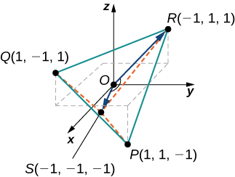

Answer: a.  b. 

174. **[T]** Find the vectors that join the center of a clock to the hours 1:00, 2:00, and 3:00. Assume the clock is circular with a radius of 1 unit.

Answer: 1:00 vector is  2:00 vector is  3:00 vector is 

175. Find the work done by force  (measured in Newtons) that moves a particle from point  to point  along a straight line (the distance is measured in meters).

Answer: 

176. **[T]** A sled is pulled by exerting a force of 100 N on a rope that makes an angle of with the horizontal. Find the work done in pulling the sled 40 m. (Round the answer to one decimal place.)

Answer: 3625.2 

177. **[T]** A father is pulling his son on a sled at an angle of  with the horizontal with a force of 25 lb (see the following image). He pulls the sled in a straight path of 50 ft. How much work was done by the man pulling the sled? (Round the answer to the nearest integer.)

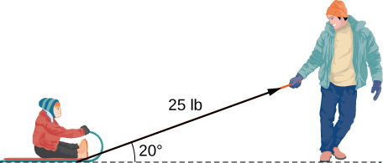

Answer: 1175 

178. **[T]** A car is towed using a force of 1600 N. The rope used to pull the car makes an angle of 25° with the horizontal. Find the work done in towing the car 2 km. Express the answer in joules () rounded to the nearest integer.

Answer: 2,900,000 J

179. **[T]** A boat sails north aided by a wind blowing in a direction of  with a magnitude of 500 lb. How much work is performed by the wind as the boat moves 100 ft? (Round the answer to two decimal places.)

Answer: 4330.13

180. Vector  represents the price of certain models of bicycles sold by a bicycle shop. Vector  represents the number of bicycles sold of each model, respectively. Compute the dot product  and state its meaning.

Answer:  and represents the revenue generated by selling the bicycles.

181. **[T]** Two forces  and  are represented by vectors with initial points that are at the origin. The first force has a magnitude of 20 lb and the terminal point of the vector is point  The second force has a magnitude of 40 lb and the terminal point of its vector is point  Let **F** be the resultant force of forces  and .

1. Find the magnitude of **F**.(Round the answer to one decimal place.)
2. Find the direction angles of **F**.(Express the answer in degrees rounded to one decimal place.)

Answer: a.  lb; b. The direction angles are   and 

182. **[T]** Consider  the position vector of a particle at time  where the components of **r** are expressed in centimeters and time in seconds. Let  be the position vector of the particle after 1 sec.

1. Show that all vectors  where  is an arbitrary point, orthogonal to the instantaneous velocity vector  of the particle after 1 sec, can be expressed as  where  The set of point *Q* describes a plane called the *normal plane* to the path of the particle at point *P*.
2. Use a CAS to visualize the instantaneous velocity vector and the normal plane at point *P* along with the path of the particle.

Answer: a. Answers will vary

b.

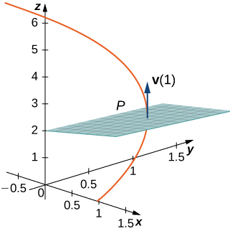

This file is copyright 2016, Rice University. All Rights Reserved.